"Store Manager Inventory Tracker - Project Documentation"
Store Manager Inventory Tracker

1. Introduction:

Project Title: Store Manager : Keep Track Of Inventory
Team ID: NM2025TMID34278
Team Leader: Azhagubhuvaneshwari G
(bhuvaniganeshan2007@gmail.com)

Team Members:

1. Krishnaveni S (krishnaveni1522007@gmail.com)
2. Sathya S (sathyasathya3078@gmail.com)
3. Kirubanithi R (kirubanithi642@gmail.com)

2. Project Overview:

Purpose:
Provide store managers with a system to track inventory, monitor stock levels, and manage products efficiently.To aid in maintaining accurate records of inventory, preventing lost sales due to stock shortages and minimizing excess inventory that ties up capital.To facilitate smoother replenishment processes by setting recorder points and triggering timely restocking.

Features:
Add, update, delete products; track stock quantities; low-stock alerts; generate inventory reports.

3. Architecture:

Data Structure: Outline how inventory items are stored (e.g., database schema or Excel sheet structure).

State Management: Describe how inventory state is updated when actions like adding or selling occur.

User Flow: Explain how a manager interacts with the system (dashboard > manage stock > generate report).

4. Setup Instructions:

Prerequisites: Software needed (e.g., Excel, MySQL, or Node.js backend if applicable).

Installation: Steps to set up the tracker locally or in a hosted environment.

5. Folder or File Structure:

Core Files: Explain where product data, reports, and utilities are stored.

Utilities: Mention helper functions like stock validation or report generation.

6. Running the Application:

Provide commands or steps to run the system (e.g., open node.js).

7. Module Documentation:

Add Product: Module to add product details like name, SKU, quantity.

Update Stock: Module to adjust stock after sales or restocks.

Reports: Module to view/export inventory reports.

8. State Management:

Global Inventory: Single source of truth for product list and counts.

Local Changes: How individual transactions update the global state.

9. User Interface:

Screenshots of dashboard, product list, stock alert pop-ups, etc.

10. Styling/UX:

Describe design choices for ease-of-use (tables, forms, color codes for stock alerts).

11. Testing:

Testing Strategy: Unit testing for modules, integration tests for updates, manual testing in Excel if applicable.

Code/Data Validation: Ensure correct stock values and avoid negative inventory.

12. Screenshots or Demo:

Provide screenshots of the inventory dashboard, add/edit product pages, and reports.
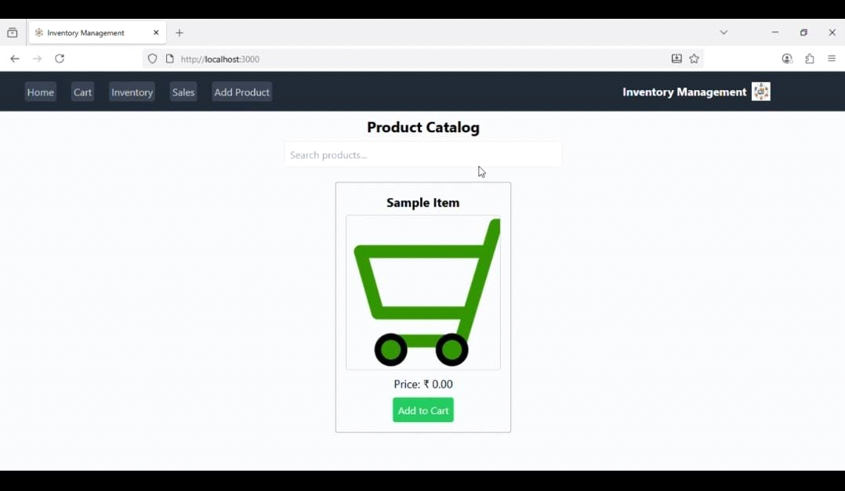
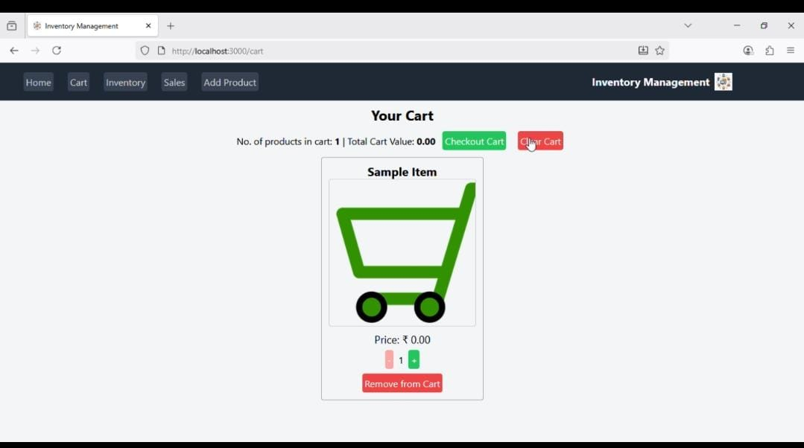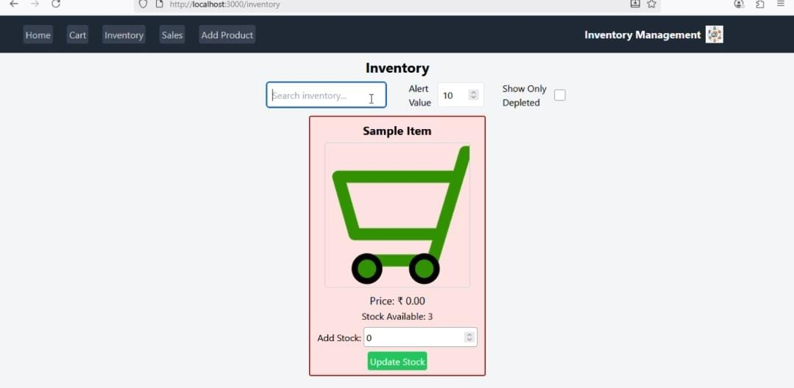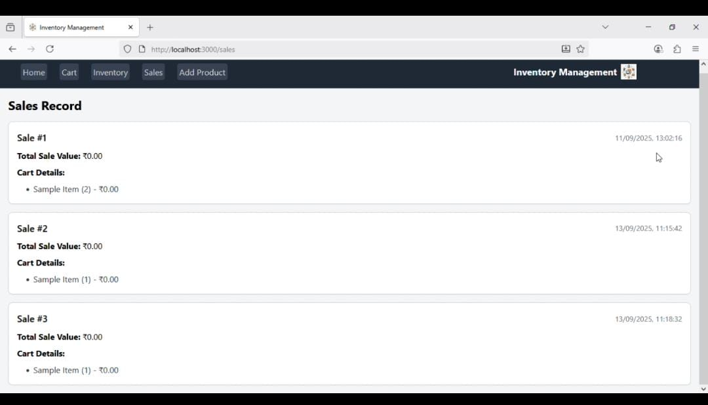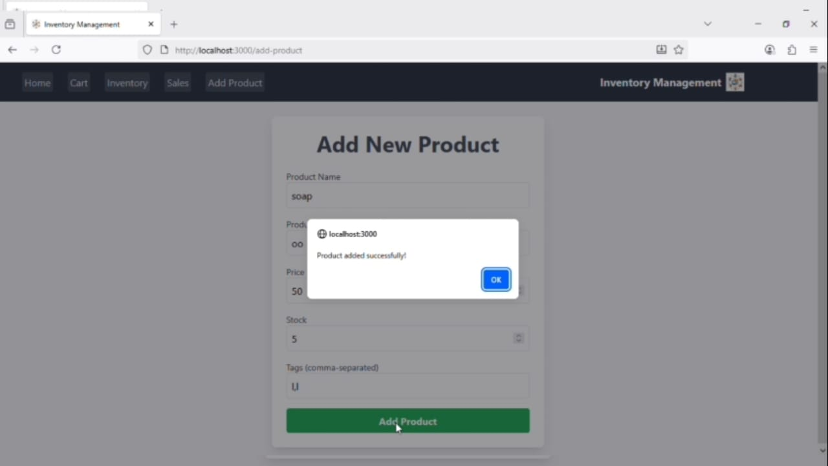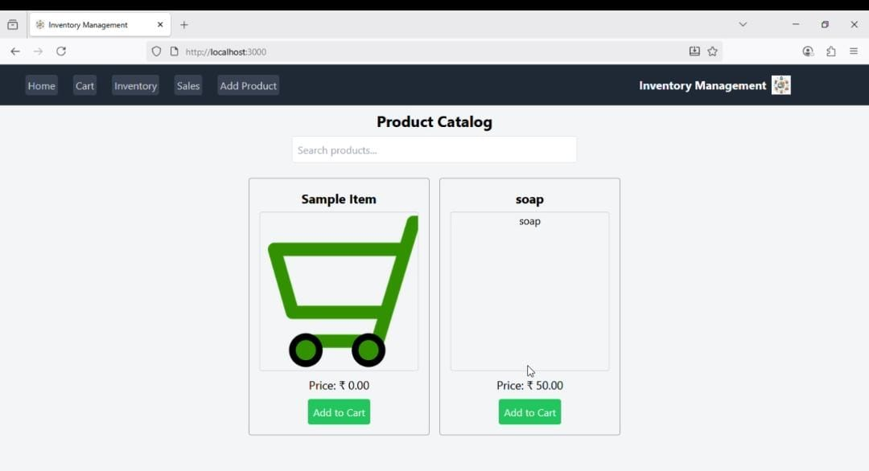
13. Known Issues:
Log any current limitation (e.g., no multi-store support)

14. Future Enhancements:
Add automated barcode scanning, sales integration, or exporty to PDF/CSV.

